**VISVESVARAYA TECHNOLOGICAL UNIVERSITY**

**JNANA SANGAMA, BELGAVI – 590018**

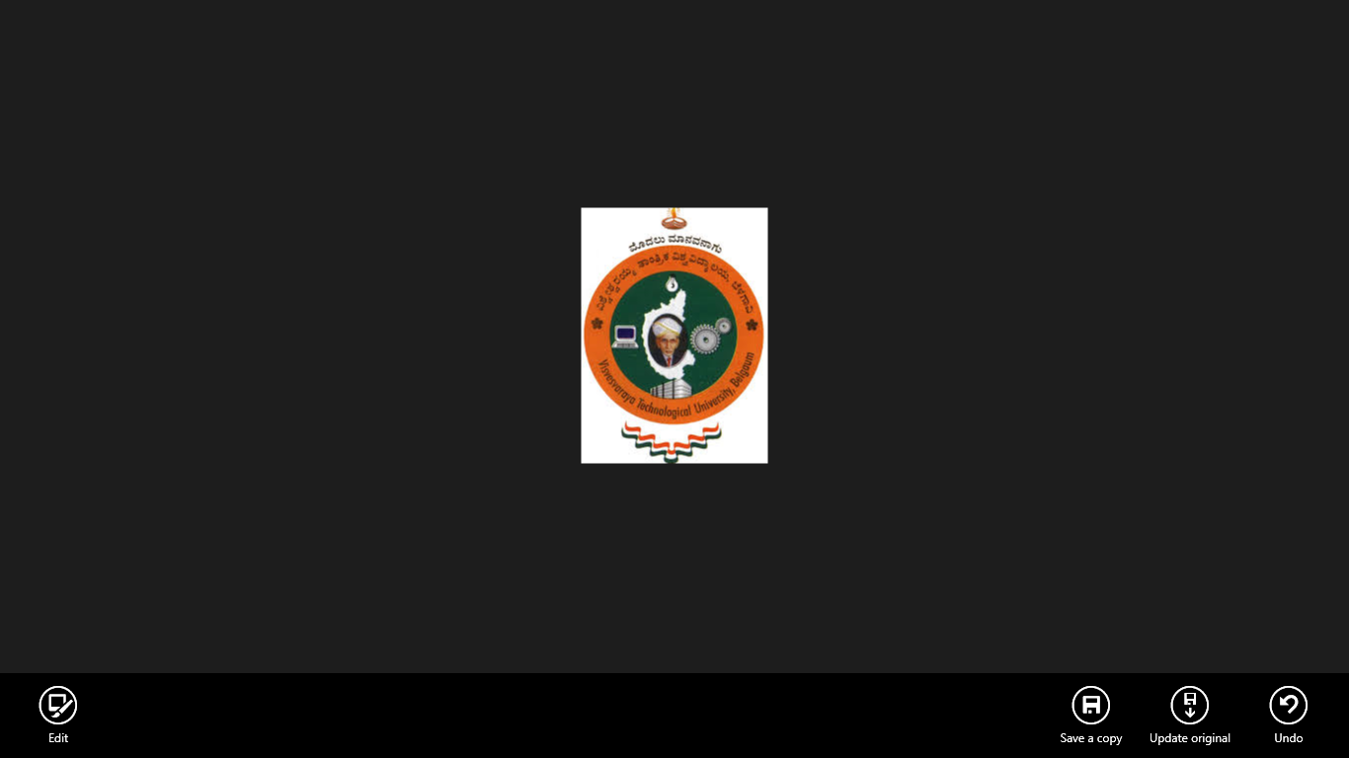

Mini Project Report On

**“HACKING BLUETOOTH HEADSET TO CONTROL A ROBOT”**

*Submitted in partial fulfilment for the award of degree*

**Bachelor of Engineering**

In

**Electronics and Communication**

BY

**ATHIKARI GANESH (1NH18EC014)**

**BANDLA SAI KUMAR(1NH18EC019)**

**BHARATH RAJ P (1NH18EC133)**

**G VENKATA VAMSI KRISHNA (1NH18EC038)**

UNDER THE GUIDANCE OF:

**Mr. DEEEPAK SIR**

**Department of Electronics and Communication Engineering**

New Horizon College of Engineering

CERTIFICATE

Certified that the mini-project entitled “**HACKING BLUETOOTH HEAD SET TO CONTROL A ROBOT**” is carried out by **ATHIKARI GANESH** bearing **USN:1NH18EC014, BANDLA SAI KUMAR** bearing**USN:1NH18EC019,BHARATH RAJ P B**earing **USN:1NH18EC133, G VENKATA VAMSI KRISHNA**  bearing **USN:1NH18EC038** students of **NEW HORIZON COLLEGE OF ENGINEERING,BENGALURU**,in partial fulfilment for the award of Bachelor of Engineering in Electronics and Communication of the Visvesvaraya Technological University,Belgavi during the year **2020-2021**

It is certified that all corrections/suggestions indicated for Internal Assessment have been incorporated in the report deposited in the department library. The mini project report has been approved as it satisfies the academic requirements in respect of the mini project work prescribed for the said degree.

Signature of the HOD Signature of theGuide

Dr.Sanjeev Sharma Mr. DEEPAK

Professor &HOD Assistant professor

Dept. of ECE Dept.of ECE

NHCE,Bengaluru NHCE,Bengaluru

**EXTERNAL VIVA**

**Name of the Examiners Signature with date**

**1.**

**2.**



ABSTRACT

**CONTENTS**

**CHAPTER 1 : INTRODUCTION**

**CHAPTER 2: COMPONENTS AND ITS DETAILS**

**CHAPTER 3:BLOCK AND CIRCUIT DIAGRAM**

**CHAPTER 4:CIRCUIT AND WORKING**

**CHAPTER 5:CONTRUCTION AND TESTING**

**CHAPTER 6:FUTURE SCOPE**

**CHAPTER 7:REFERENCES**

**CHAPTER 8:CONCLUSION**

**CHAPTER 1**

**INTRODUCTION**

In this project, an old Bluetooth headset is used, with a cell phone to make a robot controller, without any programming or microcontroller. Communication between the robot car and the smart phone is done via Bluetooth. This is an excellent hacking project and is easy to build.

The main objective of this project is to build a robot and control it without using any software or programming or microcontroller. Here we get to know about IC7805, IC MT8870, IC L293D.And we get to know about how actually a Bluetooth works and how to make PCB layout.

We're all use to wireless communication by now, even if we don't always realize it. Radio receivers and TV sets pick up programs beamed in radio waves hundreds (possibly even thousands) of km/miles through the air. Cordless telephones use similar technologies to carry calls from a handset to a base station somewhere in your home. If you use Wi-Fi (wireless internet), your computer sends and receives a steady stream of internet data to and from a router that's probably wired directly to the Net. All these technologies involve sending information back and forth not along copper cables but in radio waves buzzing invisibly through the air. Bluetooth is a similar radio-wave technology, but it's mainly designed for communicating over short distances less than about 10m or 30ft. Typically, you might use it to download photos from a digital camera to a PC , to hook up a wireless mouse to a laptop, to link a hands-free headset to your cell phone so you can talk and drive safely at the same time, and so on. We used this concept to control a robot by using a blue tooth device. Electronic gadgets that work this way have built-in radio antennas (transmitters and receivers) so they can simultaneously send and receive wireless signals to other Bluetooth gadgets. Older gadgets can be converted to work with Bluetooth using plug-in **adapters** (in the form of USB sticks, PCMCIA laptop cards, and so on). The power of the transmitter governs the range over which a Bluetooth device can operate and, generally, devices are said to fall into one of three classes: class 1 are the most powerful and can operate up to 100m , class 2 (the most common kind) operate up to 10m , and class 3 are the least powerful and don't go much beyond 1m .

Bluetooth sends and receives radio waves in a band of 79 different frequencies (**channels**) centered on 2.45 GHz, set apart from radio, TV, and cell phones, and reserved for use by industrial, scientific, and medical gadgets.

**CHAPTER2**

**COMPONENTS AND ITS DETAILS**

**SEMICONDUCTORS:**

**IC1 -7805,5V voltage regulator**

**IC2 -MT8870 DTMF receiver/decoder**

**IC3 -L293D motor driver**

**LED1 - 5mm LED**

**RESISTORS (all ¼-watt,+-5% carbon):**

**R1-R2 - 100-kilo-ohm**

**R3 -300-kilo-ohm**

**R4 - 1-kilo-ohm**

**CAPACITORS:**

**C1-C4 -0.1uF ceramic disk**

**Miscellaneous:**

**BATT.1 - 12V battery**

**M1-M2 - 12V DC geared motor ,50rpm**

**XTAL1 -3.579545MHz crystal oscillator**

**CON1 -2-Pin connector for input from Bluetooth headset**

**-nokia BH -108 orn equivalent Bluetooth headset**

**- cellphone**

**- 18 – pin and 16-pin IC socket**

**- Heat –sink for 7805**

**SEMICONDUCTORS**

**1. IC1 - 7805,5V voltage regulator**

Here Voltage sources in a circuit may have fluctuations resulting in not providing fixed voltage outputs. A transformer IC maintains the output voltage at a continuing value. 7805 IC, which is a member of 78xx series of fixed linear voltage regulators used to maintain such fluctuations, is a popular voltage regulator integrated circuit (IC).Here xx in 78xx indicates the output voltage it provides. 7805 IC provides +5 volts regulated power supply with provisions to feature a conductor .

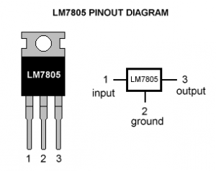

Pin Details of 7805 IC

|  |  |  |  |
| --- | --- | --- | --- |
| **Pin No.** | **Pin** | **Function** | **Description** |
| 1 | INPUT | Input voltage (7V-35V) | In this pin of the IC positive unregulated voltage is given in regulation. |
| 2 | GROUND | Ground (0V) | In this pin where the ground is given. This pin is neutral for equally the input and output. |
| 3 | OUTPUT | Regulated output; 5V (4.8V-5.2V) | The output of the regulated 5V volt is taken out at this pin of the IC regulator. |

As we have noticed that there is a significant difference between the input voltage & the output voltage of the voltage regulator. This difference between the input and output voltage is released as heat. The greater the difference between the input and output voltage, more the heat generated. If the regulator does not have a heat sink to dissipate this heat, it can get destroyed and malfunction. Hence therefore, it is advisable to limit the voltage to a maximum of 2-3 volts above the output voltage. So, we now have 2 options. Either design your circuit so that the input voltage is going into the regulator is limited to 2-3 volts above the output regulated voltage or place an appropriate heat sink , that can efficiently dissipate heat.

Schematic of 7805 IC

[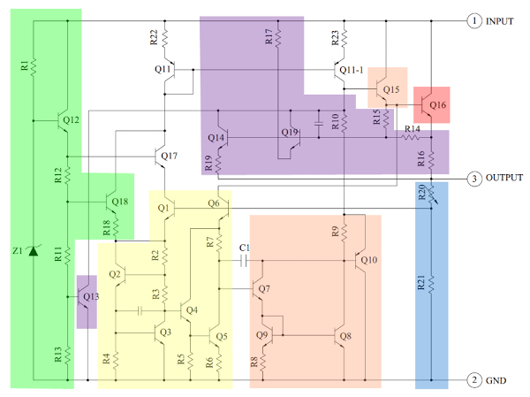](https://www.electronicsforu.com/wp-contents/uploads/2016/10/block-schematic.png)

The Heart of the 7805 IC may be a transistor (Q16) that controls the present between the input and output and thus controlling the output voltage. The band gap reference keeps the voltage stable. It takes the scaled output voltage as input (Q1 and Q6) and provides a mistake signal (to Q7) for indication if the voltage is just too high or low. The key task of the band gap is to supply a stable and accurate reference, whilst the chip’s temperature changes.

The error signal from the band gap reference is amplified by the error amplifier (orange). This amplified signal controls the output transistor through Q15. This closes the feedback loop controlling the output voltage. The startup circuit (green) provides initial current to the band gap circuit, so it doesn’t get stuck in an “off” state. The circuit in purple provides protection against overheating (Q13), excessive input voltage (Q19) and excessive output current (Q14). These circuits reduce the output current or shutdown the regulator, protecting it from damage just in case of a fault. Voltage divider (blue) scales down the voltage on the output pin to be used by the band gap reference.

Scaling the output

The 7805’s scaled output provides the input voltage (V in) to the band gap reference and band gap provides an error signal as output. The 7805’s band gap circuit removes the feedback circuit that exists inside a standard band gap reference. Instead, the entire chip becomes the feedback loop.

If the output voltage is correct (5V), then the voltage divider provides 3.75V at V in. Any change in output voltage propagates through Q6 and R7, causing the voltage at the bottom of Q7 to rise or fall accordingly. This change is amplified by Q7 and Q8, by generating the error output. The error output, in turn, decreases or increases the present through the output transistor. The feedback loop adjusts the output voltage until it's correct.

Application areas for 7805 IC

7805 IC is employed during a wide selection of circuits. The major ones being:

• Fixed-Output Regulator

• Positive Regulator in Negative Configuration

• Adjustable Output Regulator

• Current Regulator

• Adjustable DC Voltage Regulator

• Regulated Dual-Supply

• Output Polarity-Reversal-Protection Circuit

• Reverse bias projection Circuit

2. IC2 - MT8870 DTMF receiver /decoder

.• DTMF (Dual Tone Multi-Frequency) signaling is employed for telecommunication signalling over telephone line within the voice waveband between communication devices (telephone, mobile).

• it's a group of eight audio frequencies transmitted/received in pairs to represent 16 different signals.

• the phone keypad is 4x4 or 4x3 matrix of push buttons during which rows represents lower frequency component and columns represents higher frequency component which is mapped as follows.

**Table1: Telephone Keypad Tone Frequencies**

|  |  |  |  |  |
| --- | --- | --- | --- | --- |
| **FL\FH** | **1209Hz** | **1336Hz** | **1477Hz** | **1633Hz** |
| **697Hz** | 1 | 2 | 3 | A |
| **770Hz** | 4 | 5 | 6 | B |
| **852Hz** | 7 | 8 | 9 | C |
| **941Hz** | * | 0 | # | D |

• for every column and row unique frequency is assigned. No frequency is multiple of other.

• Pressing a key sends a mixture of the 2 sine frequencies like row and column.

**DTMF Encoding**

• Each DTMF tone must contain one sinusoid from high frequency group (1209, 1336, 1477, 1633) and one sinusoid from the low frequency group (697, 770, 852, 941).

• When a key's pressed, combination of low and high frequency is shipped .

• E.g. When key ‘5’ is pressed, superimposition of tones (frequencies) 770 Hz and 1336 Hz produces a tone.

• Each key pressed are often represented as a discrete signal of form as given below, **Dt[n] = A*sin (2 * pi * FH * n) + A*sin (2 * pi * FL * n), 0≤n≤N-1**

Where,

A – Amplitude

N – Number of samples

n – frequency (8 kHz)

**DTMF Decoding**

• DTMF receiver decodes dial tone and identifies which key's pressed by the user.

• The input to the decoder may be a DTMF tone that's generated by DTMF encoder.

• Decoder has Band split filter (FIR) which is centered at the frequencies of interest for decoding each key pressed.

• Band split filter section separates lower frequency tone and better frequency tone and provides it to digital decoder section

• Digital decoder verifies the frequency and duration of received tones and provides4-bit output.

For more detail, you'll refer attached DTMF Encoding and Decoding file.

There are various DTMF decoders available in market like MT8870, HT9170 etc. Out of these , MT8870 information is given below.

MT8870 Decoder

• MT8870 may be a DTMF receiver which consists of a band split filter section along side digital decoder section.

• The output of DTMF receiver is 4-bit digital, which is employed to spot the entire 16 combinations of the input as shown in below table.

**Table2: Tone Decoding**

|  |  |  |  |  |
| --- | --- | --- | --- | --- |
| **DIGIT** | **Q4** | **Q3** | **Q2** | **Q1** |
| 1 | 0 | 0 | 0 | 1 |
| 2 | 0 | 0 | 1 | 0 |
| 3 | 0 | 0 | 1 | 1 |
| 4 | 0 | 1 | 0 | 0 |
| 5 | 0 | 1 | 0 | 1 |
| 6 | 0 | 1 | 1 | 0 |
| 7 | 0 | 1 | 1 | 1 |
| 8 | 1 | 0 | 0 | 0 |
| 9 | 1 | 0 | 0 | 1 |
| 0 | 1 | 0 | 1 | 0 |
| * | 1 | 0 | 1 | 1 |
| # | 1 | 1 | 0 | 0 |
| A | 1 | 1 | 0 | 1 |
| B | 1 | 1 | 1 | 0 |
| C | 1 | 1 | 1 | 1 |
| D | 0 | 0 | 0 | 0 |
| ANY | Z | Z | Z | Z |

**Where, Z= High Impedance.**

* In most cellphones, there is only a 4 rows x 3 columns matrix keypad available i.e. only 12 tones are possible of total 16 tones.
* DTMF technique is widely used in telecom exchange room to transmit a character on telephone line for giving instruction to the operator. Also, it is used in many applications to control the devices remotely.

**Basic connection of MT8870 (DTMF)**

**The basic connection diagram of the MT8870 (DTMF) IC is shown in figure below.**

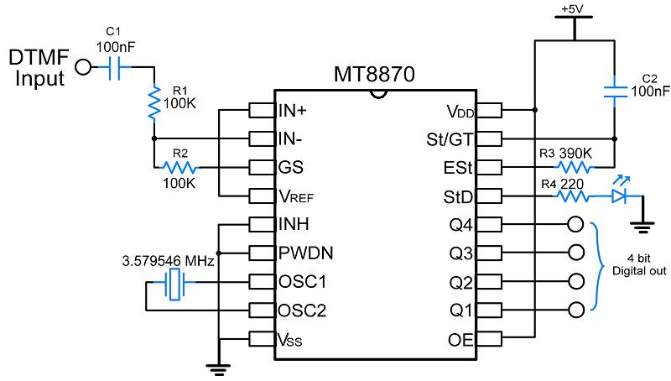

**Note: DTMF Input – Connect Audio cable from mobile to DTMF input with regard to ground.**

**Power-down and Inhibit Mode (PWDN & INH)**

• A logic high applied to pin 6 (PWDN) will power down the device to attenuate the facility consumption during a standby mode. It stops the oscillator and therefore the functions of the filters.

• Inhibit mode is enabled by a logic high input to the pin 5 (INH). It inhibits the detection of tones representing characters A, B, C and D. The output code will remain the same because the previous detected code.

**Delayed Steering Output (StD)**

• StD output presents high whenever there's new tone pair registered and updated on output latch.

• This pin is employed as signal for brand spanking new tone receive.

3. IC3 - L293D motor driver

### L293D Pin ****Configuration****

|  |  |  |
| --- | --- | --- |
| **Pin Number** | **Pin Name** | **Description** |
| 1 | Enable 1,2 | This pin enables the input pin Input 1(2) and Input 2(7) |
| 2 | Input 1 | Directly controls the Output 1 pin. Controlled by digital circuits |
| 3 | Output 1 | Connected to one end of  Motor 1 |
| 4 | Ground | Ground pins are connected to ground of circuit (0V) |
| 5 | Ground | Ground pins are connected to ground of circuit (0V) |
| 6 | Output 2 | Connected to another end of  Motor 1 |
| 7 | Input 2 | Directly controls the Output 2 pin. Controlled by digital circuits |
| 8 | Vcc2 (Vs) | Connected to Voltage pin for running motors (4.5V to 36V) |
| 9 | Enable 3,4 | This pin enables the input pin Input 3(10) and Input 4(15) |
| 10 | Input 3 | Directly controls the Output 3 pin. Controlled by digital circuits |
| 11 | Output 3 | Connected to one end of Motor 2 |
| 12 | Ground | Ground pins are connected to ground of circuit (0V) |
| 13 | Ground | Ground pins are connected to ground of circuit (0V) |
| 14 | Output 4 | Connected to another end of Motor 2 |
| 15 | Input 4 | Directly controls the Output 4 pin. Controlled by digital circuits |
| 16 | Vcc2 (Vss) | Connected to +5V to enable IC function |

### Features

• are often wont to run Two DC motors with an equivalent IC.

• Speed and Direction control is feasible

• Motor voltage Vcc2 (Vs): 4.5V to 36V

• Maximum Peak motor current: 1.2A

• Maximum Continuous Motor Current: 600mA

• Supply Voltage to Vcc1(vss): 4.5V to 7V

• Transition time: 300ns (at 5Vand 24V)

• Automatic Thermal shutdown is out there

• Available in 16-pin DIP, TSSOP, SOIC packages

**RESISTORS**

* 1. **R1-R2 -100-kilo-ohm**

### .A resistor could even be a passive two-terminal electrical component that implements electric resistance as a circuit element. Resistors act to scale back current flow, and, at an equivalent time, act to lower voltage levels within circuits. In electronic circuits, resistors are wont to limit current flow, to manage signal levels, bias active elements, and terminate transmission lines among other uses.

### ****Features of 100 Kilo OHM-1/4 Watt Resistor****

### • Resistance: 100 Kilo Ω.

### • Tolerance: 5%.

### • Power rating: 1/4Watt.

### ****Applications of 100 Kilo OHM-1/4 Watt Resistor****

• Voltage limiter.

• Current Limiter.

• DIY projects requiring lower voltage than specified voltage.

2. R3 -300-KILO-OHM

### ****Features of 300Kilo Ohm-1/4 Watt Resistance****

* **• Resistance: 300KΩ**
* **• Tolerance: 5%.**
* **• Power rating: 1/4Watt..**

### ****Applications of 300Kilo Ohm-1/4 Watt Resistance****

* **Voltage limiter.**
* **Current Limiter.**
* DIY projects requiring series/**shunt resistance**.

**3. R4 -1-KILO-OHM**

### ****Features of 1.0 Kilo Ohm-1/4 Watt Resistance:****

### Resistance: 1.0K Ω.

### • Tolerance: 5%.

### • Power rating: 1/4Watt.

### ****Application of 1.0 Kilo Ohm-1/4 Watt Resistance:****

**• Voltage limiter.**

**• Current Limiter.**

**• DIY projects requiring lower voltage than specified voltage.**

**CAPACITORS**

* 1. **C1-C4 - 0.1Uf ceramic disk**

A capacitor could even be a tool that stores electricity in an electrical field. it is a passive electronic component with two terminals.

The effect of a capacitor is understood as capacitance. While some capacitance exists between any two electrical conductors in proximity during a circuit, a capacitor could even be a component designed to feature capacitance to a circuit. The capacitor was originally mentioned as a condenser or condensator.[1] This name and its cognates are still widely utilized in many languages, but rarely in English, one notable exception being condenser microphones, also called capacitor microphones.

The physical form and construction of practical capacitors vary widely and far of sorts of capacitor are in common use. Most capacitors contain a minimum of two electrical conductors often within the sort of metallic plates or surfaces separated by a dielectric medium. A conductor could even be a foil, thin film, sintered bead of metal, or an electrolyte. The nonconducting dielectric acts to extend the capacitor's charge capacity. Materials commonly used as dielectrics include glass, ceramic, film , paper, mica, air, and oxide layers. Capacitors are widely used as parts of electrical circuits in many common electrical devices. Unlike a resistor, a perfect capacitor doesn't dissipate energy, although real-life capacitors do dissipate alittle amount. (See Non-ideal behavior) When an electrical potential, a voltage, is applied across the terminals of a capacitor, as an example when a capacitor is connected across A battery , an electrical field develops across the dielectric, causing a net charge to gather on one plate and net charge to gather on the opposite plate. No current actually flows through the dielectric. However, there's a flow of charge through the source circuit. If the condition is maintained sufficiently long, this through the source circuit ceases. If a time-varying voltage is applied across the leads of the capacitor, the source experiences an ongoing current thanks to the charging and discharging cycles of the capacitor.

**MISCELLANEOUS**

**1. BATT1 -12V BATTERY**

A battery could even be a tool consisting of 1 or more electrochemical cells with external connections[1] for powering electrical devices like flashlights, mobile phones, and electric cars. When A battery is supplying electrical power , its positive terminal is that the cathode and its negative terminal is that the anode.[2] The terminal marked negative is that the source of electrons which may flow through an external circuit to the positive terminal. When A battery is connected to an external electric load, a redox reaction converts high-energy reactants to lower-energy products, and thus the free-energy difference is delivered to the external circuit as electricity .[3] Historically the term "battery" specifically mentioned a tool composed of multiple cells, however the usage has evolved to incorporate devices composed of 1 cell.

Primary (single-use or "disposable") batteries are used once and discarded, because the electrode materials are irreversibly changed during discharge; a typical example is that the alkaline battery used for flashlights and a multitude of portable electronic devices. Secondary (rechargeable) batteries are often discharged and recharged multiple times using an applied electric current; the first composition of the electrodes are often restored by reverse current. Examples include the lead-acid batteries utilized in vehicles and lithium-ion batteries used for portable electronics like laptops and mobile phones.

Batteries are available many shapes and sizes, from miniature cells used to power hearing aids and wristwatches to small, thin cells utilized in smartphones, to large lead acid batteries or lithium-ion batteries in vehicles, and at the foremost important extreme, huge battery banks the dimensions of rooms that provide standby or emergency power for telephone exchanges and computer data centers.

Batteries have much lower specific energy (energy per unit mass) than common fuels like gasoline. In automobiles, this is often often often somewhat offset by the upper efficiency of electrical motors in converting energy to mechanical work, compared to combustion engines.

**2. M1-M2 - 12V DC geared motor ,50 rpM**

.A DC motor is any of a category of rotary electrical motors that converts DC electricity into energy . The most common types believe the forces produced by magnetic fields. Nearly all kinds of DC motors have some internal mechanism, either electromechanical or electronic, to periodically change the direction of current partially of the motor.

DC motors were the primary sort of motor widely used, as they might be powered from existing direct-current lighting power distribution systems. A DC motor's speed are often controlled over a good range, using either a variable supply voltage or by changing the strength of current in its field windings. Small DC motors are utilized in tools, toys, and appliances. The universal motor can operate DC but may be a lightweight brushed motor used for portable power tools and appliances. Larger DC motors are currently utilized in propulsion of electrical vehicles, elevator and hoists, and in drives for steel rolling mills. The advent of power electronics has made replacement of DC motors with AC motors possible in many applications.

A coil of wire with a current running through it generates an electromagnetic field aligned with the middle of the coil. The direction and magnitude of the magnetic flux produced by the coil are often changed with the direction and magnitude of the present flowing through it.

A simple DC motor features a stationary set of magnets within the stator and an armature with one or more windings of insulated wire wrapped around a soft iron core that concentrates the magnetic field. The windings usually have multiple turns round the core, and in large motors there are often several parallel current paths. The ends of the wire winding are connected to a commutator. The commutator allows each armature coil to be energized successively and connects the rotating coils with the external power supply through brushes. (Brushless DC motors have electronics that switch the DC current to every coil on and off and haven't any brushes.)

The total amount of current sent to the coil, the coil's size and what it's wrapped around dictate the strength of the electromagnetic field created.

The sequence of turning a specific coil on or off dictates what direction the effective electromagnetic fields are pointed. By turning on and off coils in sequence a rotating magnetic flux are often created. These rotating magnetic fields interact with the magnetic fields of the magnets (permanent or electromagnets) within the stationary a part of the motor (stator) to make a torque on the armature which causes it to rotate. In some DC motor designs the stator fields use electromagnets to make their magnetic fields which permit greater control over the motor.

At high power levels, DC motors are nearly always cooled using forced air.

Different number of stator and armature fields also as how they're connected provide different inherent speed/torque regulation characteristics. The speed of a DC motor are often controlled by changing the voltage applied to the armature. The introduction of variable resistance within the armature circuit or field circuit allowed speed control. Modern DC motors are often controlled by power electronics systems which adjust the voltage by "chopping" the DC current into on and off cycles which have an efficient lower voltage.

**3.XTAL1 - 3.579545MHz crystal oscillator**

A quartz oscillator is an electronic oscillator circuit that uses the mechanical resonance of a vibrating crystal of piezoelectric material to make an electrical signal with a particular frequency.[1][2][3] This frequency is usually wont to keep track of your time , as in quartz wristwatches, to supply a stable clock signal for digital integrated circuits, and to stabilize frequencies for radio transmitters and receivers. The most common sort of piezoelectric resonator used is that the quartz , so oscillator circuits incorporating them became referred to as crystal oscillators,[1] but other piezoelectric materials including polycrystalline ceramics are used in similar circuits.

A quartz oscillator , particularly one employing a quartz , works by distorting the crystal with an electrical field, when voltage is applied to an electrode near or on the crystal; a property known as electrostriction or inverse piezoelectricity. When the electric field is removed, the quartz—which oscillates at a precise frequency—generates an electric field as it returns to its previous shape, and this will generate a voltage. The result's that a quartz behaves like an RLC circuit, but with a way higher Q.

Quartz crystals are manufactured for frequencies from a couple of tens of kilohertz to many megahertz. More than two billion crystals are manufactured annually.[citation needed] Most are used for consumer devices such as wristwatches, clocks, radios, computers, and cellphones. Quartz crystals also are found inside test and measurement equipment, like counters, signal generators, and oscilloscopes.

A crystal may be a solid during which the constituent atoms, molecules, or ions are packed during a regularly ordered, repeating pattern extending altogether three spatial dimensions.

Almost any object made from an elastic material might be used sort of a crystal, with appropriate transducers, since all objects have natural resonant frequencies of vibration. For example, steel is extremely elastic and features a high speed of sound. It was often utilized in mechanical filters before quartz. The resonant frequency depends on size, shape, elasticity, and the speed of sound in the material. High-frequency crystals are typically cut within the shape of an easy rectangle or circular disk. Low-frequency crystals, like those utilized in digital watches, are typically cut within the shape of a implement . For applications not needing very precise timing, a low-cost ceramic resonator is usually utilized in place of a quartz .

When a crystal of quartz is correctly cut and mounted, it are often made to distort in an electrical field by applying a voltage to an electrode near or on the crystal. This property is understood as electrostriction or inverse piezoelectricity. When the sector is removed, the quartz generates an electrical field because it returns to its previous shape, and this can generate a voltage. The result's that a quartz behaves like an RLC circuit, composed of an inductor, capacitor and resistor, with a particular resonant frequency.

Quartz has the further advantage that its elastic constants and its size change in such how that the frequency dependence on temperature are often very low. The specific characteristics depend upon the mode of vibration and therefore the angle at which the quartz is cut (relative to its crystallographic axes).[11] Therefore, the resonant frequency of the plate, which depends on its size, does not change much. This means that a quartz clock, filter or oscillator remains accurate. For critical applications the crystal oscillator is mounted during a temperature-controlled container, called a crystal oven, and may even be mounted on shock absorbers to stop perturbation by external mechanical vibrations.

**Heat sink for 7805**

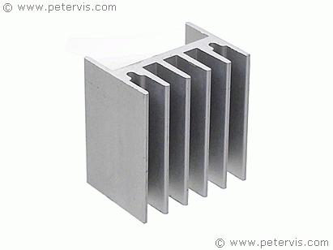

A conductor may be a piece of metal engineered to dissipate the utmost thermal energy into the ambient surroundings. It assists a component to stay below its maximum operating junction temperature by drawing this energy away, thereby preventing damage through excessive temperatures. All electronic components dissipate heat, and usually their package (body) is sufficient to dissipate it into the surroundings, however voltage regulators such as a 7805, 7812, LM317T, require assistance if they're to work to their extreme limits.

This article is not about how to make a heat sink for a voltage regulator; rather, it is about how to determine if a heat sink is required, and how to choose one with the proper size. There are many manufacturers, and many electronics shops supplying them, however their use tends to be sporadic. Most of the time engineers and students overlook their requirement. Part of the reason for this is that there is nothing on the internet to show how to calculate the required size and consequently, it takes less time to buy and fit it, then do the mathematics for its requirement!

This multi-page article shows how to determine if a heat sink is required, how to calculate its size, and, how to select one using the parameters given in the documentation sheet of the component.

This is analogous to Ohm’s Law where one might say that wood is poor conductor of electricity and has a high electrical resistance, however copper is a good conductor of electricity and therefore has a low electrical resistance.

Thermal resistance has the units °C/W, or temperature divided by watts in simple terms. When you go to the shops to buy a heat sink, it will have a rating value in these units. Obviously, this value reflects its ability to dissipate heat energy into the surroundings.

**CHAPTER 3**

**BLOCK DIAGRAM AND CIRCUIT DIAGRAM**

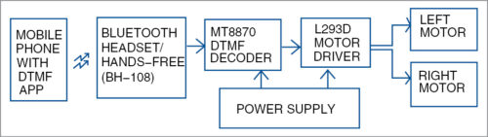

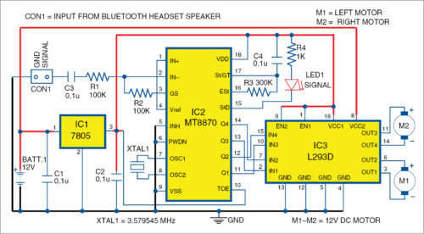

**CHAPTER 4**

**CIRCUIT AND WORKING**

The block diagram shows how the Bluetooth headset/hands-free can be connected to DTMF receiver, motor driver and power supply. Heart of the circuit is the dual-tone multiple frequency (DTMF) MT8870 decoder. Fig the complete circuit diagram of the receiver system.

Operating voltage of MT8870 (IC2) is 5V, which is provided by 7805 voltage regulator (IC1). IC2 makes use of a 3.579545MHz crystal oscillator (XTAL1). Input at connector CON1 is an audio signal, which is provided by Bluetooth headset (Nokia BH-108 in this case).

Open Nokia BH-108 Bluetooth headset by removing its top panel, exposing the circuit as shown in Fig. Locate its speaker output terminals (SPK+ and SPK-) on the circuit card . Solder two thin wires onto speaker terminals. Connect the red (signal) wire to input of MT8870 IC through CON1, a filter capacitor C3 (0.1µF) and resistor R1 (100-kilo-ohm).

Make complete connections as shown in the circuit. Output of MT8870 IC goes to the motor control circuit, hence, controlling the two motors (M1 and M2). L293D is used as the motor driver/controller.

Install an Android app that outputs DTMF tones on the cell phone, whose Bluetooth is paired with Nokia BH-108 Bluetooth headset. Install the app on the cell phone for outputting audio through Bluetooth (such as mono Bluetooth). Now, according to the key pressed in the GUI of the app, the robot will move as per the table. For example, when key A is pressed on the app, output states are 1 0 1 0 for Q4 Q3 Q2 Q1, respectively. As per connections and polarities of motors with output pins of IC3, the robot will move in forward direction. Press 3 to stop the robot.

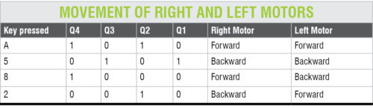

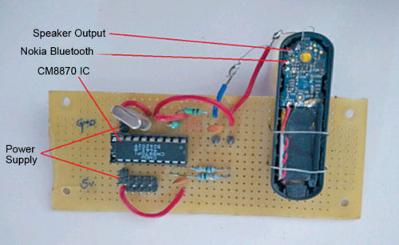

**CHAPTER 5**

**CONSTRUCTION AND TESTING**

A PCB layout of the robot is shown in Fig and its components layout in Fig. The robot car is built using two geared motors for rear wheels and a castor wheel on the front. Connect the left and right motors (M1 and M2) to output pins (out1 through out4) of L293D motor driving circuit. Outputs Q1 through Q4 of DTMF IC2 are connected to L293D inputs.

Power supply is provided through a 12V lead-acid battery. For MT8870 and L293D, power supply is provided via 7805 voltage regulator. Bluetooth headset has an inbuilt battery that can be charged using an ordinary phone charger. Charge Bluetooth headset and then pair it with the phone’s Bluetooth.

There are many apps available for DTMF tone generation, such as DTMF by Wolphi LLC. For customisation, or to build your own app of DTMF application, MIT App Inventor can be used. Tonedef app for Android was used during testing at EFY Lab. With this app, you need two cellphones: one (say, A) with DTMF app installed and in user’s hand, and the second cellphone (say, B) with auto answering mode enabled and wirelessly connected to Nokia-BH-108 Bluetooth headset.

The robot is controlled from the first cellphone after connection is established with the second cellphone. Advantage here is that you do not have to keep the second phone on the robot along with Nokia BH-108 Bluetooth headset.

Keep both cellphones with you. Dial the number of phone B from phone A. Once calling is established between the two phones, open DTMF app on phone A. You will see a virtual dialpad. Touch the appropriate number as per the table to control the robot in forward, backward, right or left directions. DTMF signal from phone A is transmitted and received by DTMF decoder MT8870 through BH-108 Bluetooth headset mounted on the robot’s chassis..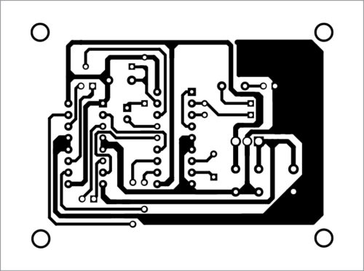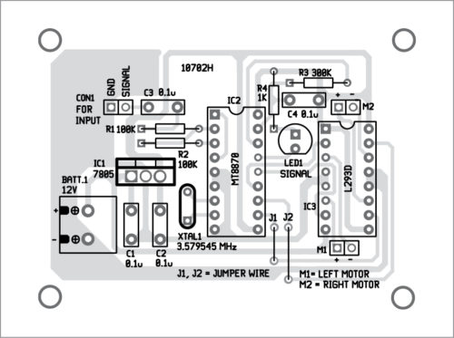

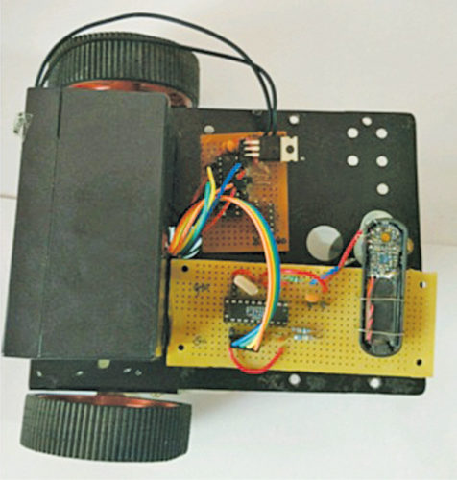

**CHAPTER 6**

**FUTURE SCOPE**

* **It can be used by the cops to track criminals where they cant follow them and where there is no internet.**
* **It doesn’t require any software or programming to control the robot**
* **It is used to transport less weight goods in the industries**
* **It can be used for domestic purposes**

**CHAPTER 7**

**REFERENCES**

**Web references**

* **Electronicsforu.com**
* **Hackaday.com**

**Youtube references**

* **Electronicsforu.com**

**CHAPTER 8**

**CONCLUSION**

**So basically here a mobile phone with DTMF app sends signals to a Bluetooth headset which is connected to a MT8870 DTMF DECODER which in turn is connected to L273D MOTOR DRIVER ,both connected to power supply and L293Dconnected to left motor and right motor where the wheel of the robot moves –left, right, back, front as per the instructions given in the cell phone .This simple project helps cops to track the criminals without any programming or microcontroller and also help industries to move the goods from one place to other ,and also in it is used in domestic purposes.**